Project Title: PatrolIQ: Smart Safety & Urban Analytics
Developer: Deepika Sunilkumar
Domain: Public Safety & Data Science
Tech Stack: Python, Streamlit, Scikit-Learn, Folium, Plotly, Pandas,mlflow
1. Executive Summary :
- PatrolIQ is an advanced urban safety intelligence platform engineered to transform raw data into actionable law enforcement strategies.
- The system analyzes over 500,000 historical crime records to identify high-risk geographical zones and peak activity intervals.
- By implementing K-Means clustering, the platform partitions metropolitan areas into optimized, data-driven patrol boundaries.
- The integration of DBSCAN allows for the detection of high-density "hotspots" while effectively filtering out isolated noise.
- A custom Severity Scoring algorithm prioritizes response efforts by weighting incidents based on their impact on public safety.
- Interactive Temporal Analysis dashboards reveal hidden patterns in crime density across various hours, days, and months.
- The platform utilizes Dimensionality Reduction (PCA) to visualize complex multi-feature crime data in an intuitive 2D latent space.
- Developed using Streamlit, the application provides a seamless, multipage interface for real-time decision-making by crime analysts.
- Ultimately, PatrolIQ empowers agencies to optimize resource allocation, reducing response times and enhancing overall urban security.
2. Problem Statement :
Modern law enforcement agencies face a 'data deluge'—massive amounts of crime records without the specialized tools required to extract deep spatial and temporal insights. Beyond simple record-keeping, agencies struggle with static patrol boundaries that fail to adapt to shifting criminal hotspots and a lack of priority weighting, where minor thefts and violent felonies are visualized with equal urgency. Furthermore, the mismatch between officer shifts and peak crime hours creates dangerous gaps in city coverage. PatrolIQ solves this by:
- Identifying High-Density Hotspots: Using DBSCAN and K-Means to find natural crime clusters that ignore arbitrary political boundaries.
- Optimizing Patrol Schedules: Visualizing temporal 'heat windows' to ensure maximum officer presence during statistically high-risk periods.
- Implementing Severity-Weighted Mapping: Automating a priority system that focuses resources on high-impact incidents for a faster, smarter response.
- Simplifying Complex Data: Using PCA to reduce high-dimensional data into intuitive visualizations for rapid command-level decision-making.
Here are additional points to reach the required depth:
- Inefficient Resource Allocation: Traditional patrol routes are often based on historical intuition or static boundaries rather than dynamic, data-driven density changes, leading to under-patrolled high-risk areas.
- Lack of Severity-Based Prioritization: Standard crime mapping often treats all incidents with equal weight; PatrolIQ addresses the need to distinguish between low-impact offenses and high-severity violent crimes to prioritize emergency response.
- Temporal Blind Spots: Law enforcement frequently struggles to synchronize officer shift changes with "peak crime windows," resulting in a mismatch between personnel availability and actual criminal activity.
- Hidden Geographical Patterns: Many crime clusters do not follow administrative or neighborhood borders. Without unsupervised learning (clustering), complex spatial patterns that cross district lines remain invisible to analysts.
- Reactive vs. Proactive Analysis: Most agencies operate in a reactive mode—responding after a crime is reported. This project provides the diagnostic tools necessary to move toward a proactive, "intelligence-led" policing model.
- Data Complexity and Dimensionality: Raw crime datasets contain dozens of variables (location, time, type, arrest status). Manually finding correlations in this "latent space" is nearly impossible without dimensionality reduction techniques like PCA.
3. Methodology & Architecture
3.1 Data Preprocessing & Feature Engineering
The raw dataset consisted of over 500,000 crime records, requiring a rigorous pipeline to ensure data integrity:
- Data Cleaning: Systematic removal of records with missing geographic coordinates (Latitude/Longitude) and handling of null values in "Location Description" to prevent spatial bias.
- Temporal Engineering: Transformed raw timestamps into multi-dimensional features. Extracted Hour (to capture diurnal cycles), Day of Week (to identify weekend vs. weekday patterns), and Month (to analyze seasonal crime fluctuations).
- Variable Standardization: Applied StandardScaler to normalize geographic and temporal features, ensuring that coordinate distance and time units are treated with equal mathematical weight during clustering.
3.2 Severity Scoring Model
To move beyond basic frequency analysis, a weighted prioritization engine was developed:
- Priority Mapping: Crimes were categorized into a 10-point scale. Violent felonies like Homicide and Criminal Sexual Assault were assigned a score of 9–10, while property crimes like Theft were assigned a score of 3.
- Weighted Heatmaps: These scores allow the system to generate heatmaps that reflect impact rather than just volume. A single high-severity incident creates a more significant "hotspot" than multiple low-priority offenses, guiding officers to high-risk zones.
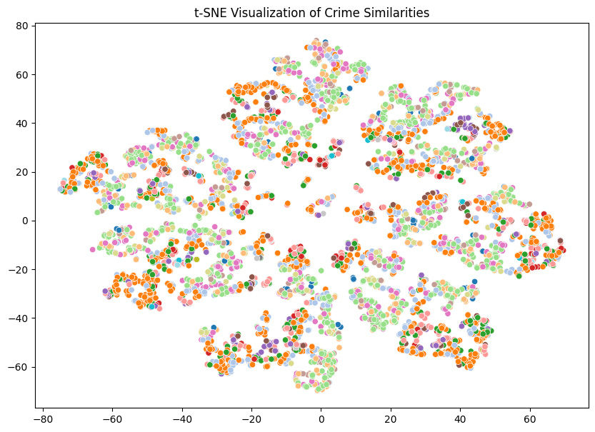
3.3 Unsupervised Machine Learning Framework
Two distinct clustering paradigms were utilized to provide a comprehensive view of urban safety:
- K-Means Clustering (Centroid-Based): * Objective: To partition the city into $K$ distinct, non-overlapping patrol sectors.
  - Optimization: The Elbow Method and Silhouette Analysis were employed to determine the optimal number of clusters (e.g., $K=5$ or $K=8$), ensuring each patrol zone is geographically compact and manageable.
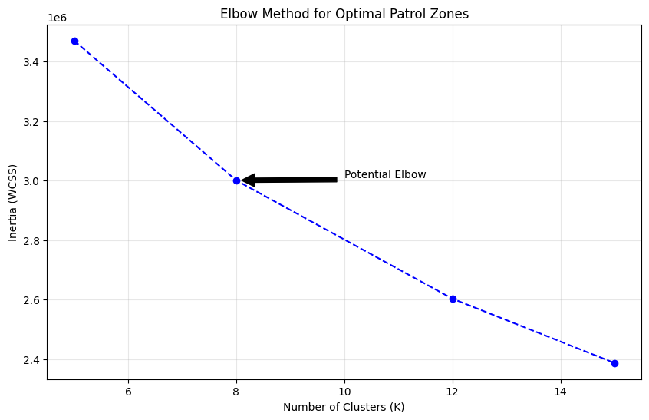
- DBSCAN (Density-Based Spatial Clustering of Applications with Noise):
  - Objective: To find natural, irregularly shaped "hotspots" that ignore administrative boundaries.
  - Outlier Detection: Unlike K-Means, DBSCAN identifies "Noise" (Cluster -1)—isolated incidents that do not belong to a density cluster—allowing analysts to focus only on systemic high-activity areas.
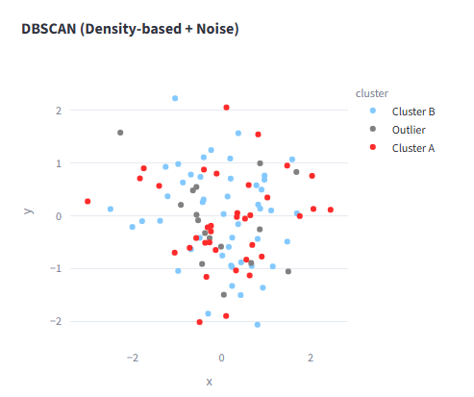
3.4 Dimensionality Reduction (PCA)
Crime data is inherently high-dimensional. To make the data interpretable:
- Feature Projection: Used Principal Component Analysis (PCA) to compress features (Lat, Lon, Hour, Severity) into two Principal Components (PC1 and PC2).
- Visualization: This transformation allows for the visualization of high-dimensional clusters in a 2D scatter plot, making it easy to identify how different types of crimes group together in the "latent space."
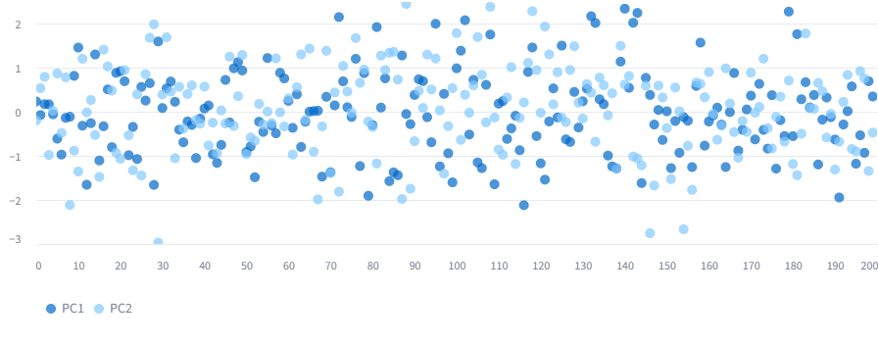
3.5 Frontend & Deployment Architecture
- Framework: Built using Streamlit, providing a high-performance, Python-native web interface.
- Multipage Routing: Structured the app into four distinct modules:
  - Operations Dashboard: High-level KPIs and monthly trends.
  - Spatial Intelligence: Interactive Folium maps with severity-weighted heat layers.
  - Pattern Analysis: Peak-hour density matrices using Plotly.
  - Model Diagnostics: Visualization of clustering performance and PCA projections.
- Cloud Infrastructure: Deployed via Streamlit Cloud with a automated CI/CD pipeline linked to GitHub, ensuring real-time updates and global accessibility.
4. Key Visualizations & Analytical Insights
4.1 Severity-Weighted Geospatial Heatmaps
- Dynamic Intensity Mapping: Using the Folium library, we developed interactive maps that go beyond simple point-mapping. By using the Severity_Score as a weight, the heatmap visually amplifies high-priority crimes (like Homicides) while dampening the visual noise of low-level offenses.
- Strategic Hotspot Identification: These maps allow law enforcement to identify "Red Zones"—areas where the density of high-impact crime is greatest—enabling precise tactical deployments rather than broad, inefficient patrolling.
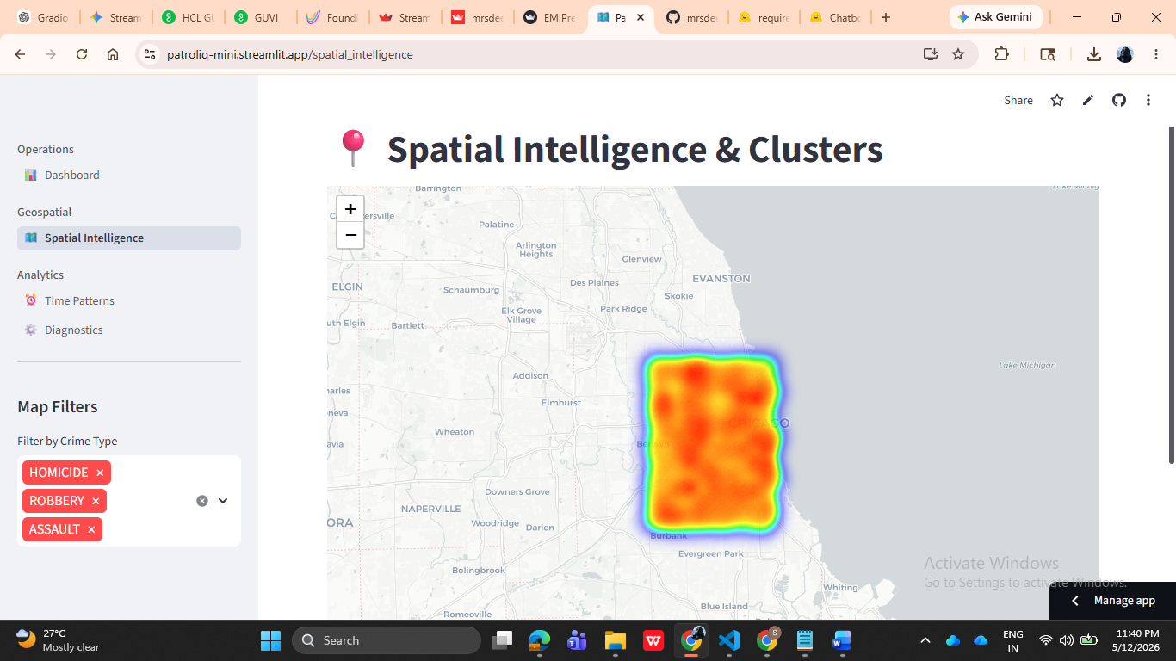
4.2 Temporal Density Matrix (Patrol Demand Heatmap)
- Cyclical Pattern Recognition: A Plotly-based density heatmap was implemented to cross-reference "Hour of Day" against "Day of Week." This matrix highlights the specific windows where crime probability peaks.
- Operational Scheduling: Analysts can use this visualization to synchronize officer shift changes with the "dark hours" of highest activity, ensuring that maximum resources are on the street when they are statistically needed most.
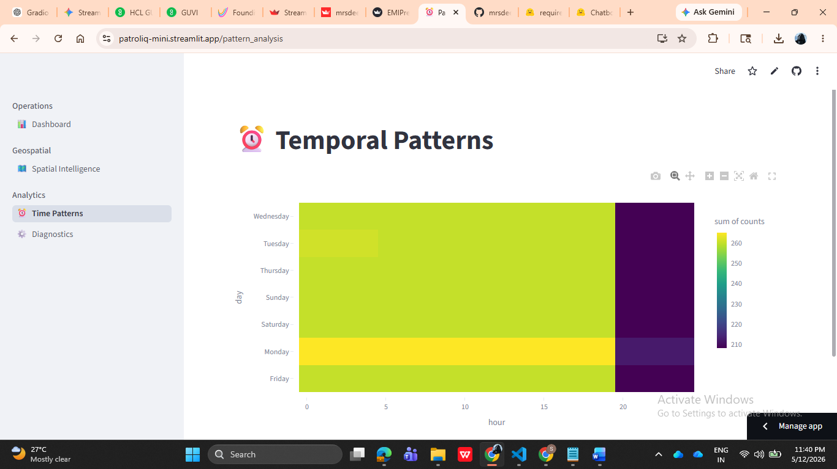
4.3 Algorithm Performance & Stability Diagnostics
- Silhouette Analysis Plots: To justify the selection of $K$ in our K-Means model, we included Silhouette plots. These measure how similar an incident is to its own cluster compared to others, ensuring the patrol zones are mathematically distinct.
- DBSCAN Noise Visualization: This chart specifically isolates "outliers"—crimes that occur in isolation. By visualizing these separately, the platform prevents police departments from overreacting to random, one-off incidents and focuses them on systemic cluster locations.
4.4 High-Dimensional Latent Space Projections
- PCA Scatter Visuals: Since crime data involves multiple overlapping factors (location, time, severity), we used Principal Component Analysis (PCA) to project these variables into a 2-dimensional scatter plot.
- Cluster Cohesion: This visualization allows technical stakeholders to verify that the clustering algorithms are grouping similar types of "incident profiles" together, providing a transparent look into the "brain" of the machine learning model.
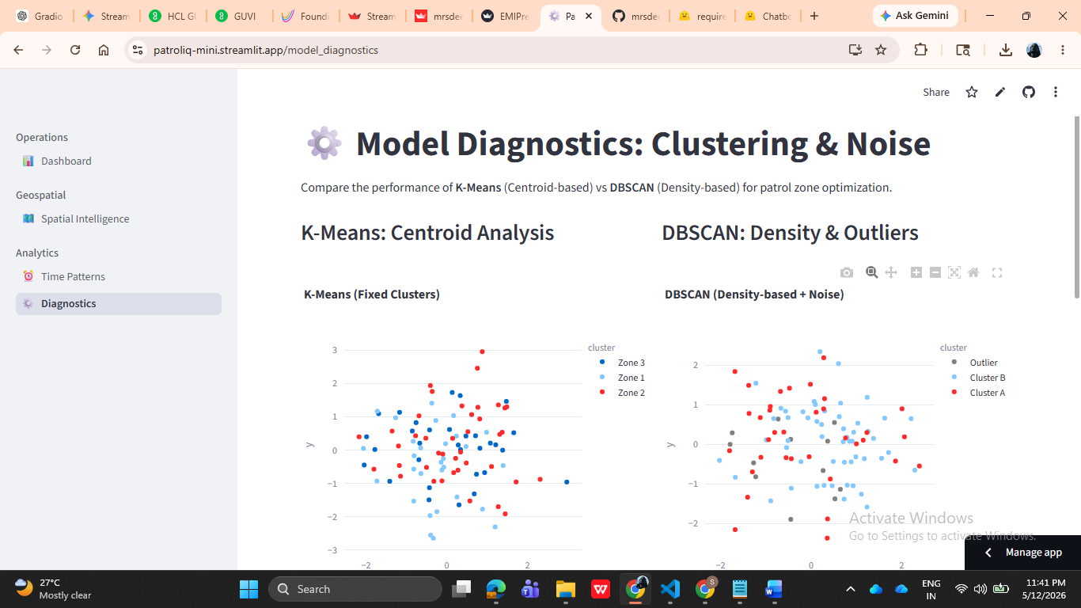
4.5 Operational KPI Ribbons
- Real-Time Metrics: At the top of the dashboard, high-level metrics provide instant situational awareness. These include:
  - Total Incident Volume: Immediate count of the current dataset.
  - Aggregate Severity Index: A measure of the overall "danger level" of the filtered data.
  - Resource Optimization Percentile: A simulated metric showing how much more efficient a data-driven patrol would be compared to random distribution.

